BANGKOK 4 DAYS 3 NIGHTS (MUSALIM)
Private
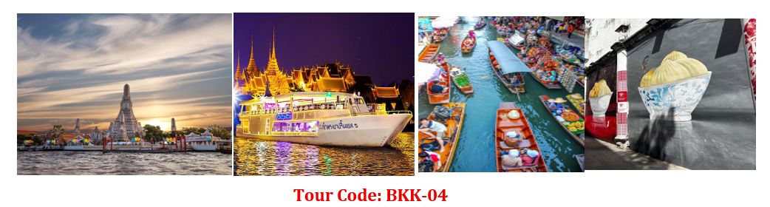

Tour Highlights • Wat Arun (Temple of Dawn)• Chao Phraya Princess Cruise
• Damnoen Saduak Floating Market
🌴 Complimentary Drink: Young Coconut or Thai Tea
DAY 01 — Arrival in Bangkok ( NO meal)
• Assemble at airport for flight to Bangkok
• Visit Songwat Road Street ART
• Explore Sampheng Wholesale Market
• Enjoy Bantadthong Night Street Food
DAY 02 — Bangkok (Breakfast / Lunch / Own Dinner)
• Visit Damnoen Saduak Floating Market (boat ride included)
→ Experience local merchants selling goods from traditional boats
• Mae Klong Railway Market – The market that operates right on train tracks!
• Shopping at Platinum Fashion Mall and Big C Supermarket
• Lunch included / Dinner at your own arrangement
DAY 03 — Bangkok (Breakfast / Lunch / Dinner)
• Wat Arun – Boat ride along the Chao Phraya River & visit the iconic temple
• Golden Buddha Temple – Admire the 5.5-tonne solid gold statue
• Free time shopping at IconSiam Mall
• Dinner & Sunset Cruise at Asiatique Riverfront aboard the Chao Phraya Princess Cruise
DAY 04 — Departure (Breakfast)• Transfer to airport for flight home
✈️ Bringing back wonderful memories & superb souvenirs!
Special Note: Pada hari Jumaat ada solat di masjid (Friday Prayer at Mosque

